Team Member Performance Evaluation Form
Department of Electrical and Computer Engineering
Howard University

Date: (Note: Evaluate yourself too)

Project Title:

Evaluator's Name:

Evaluation Guide (Read Carefully):
1. For each of the 10 items below, each project team receives $500 per person. For example, if a team has two members, the team receives $500 x 2 = $1,000. A three-member team receives $1,500.
2. The evaluator now distributes, for each of 10 items, the team’s money to each of the members (including him/her-self) by the relative performance of the members of the item. Therefore the sum of the money distributed to each member at each row must be the same as the money the team receives.
3. Example
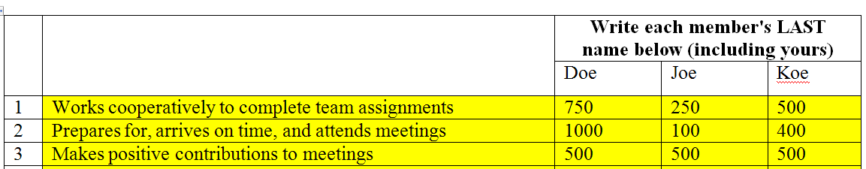

Peer Evaluation

 |  | Write each member's LAST name below (including yours)
1 | Works cooperatively to complete team assignments
2 | Prepares for, arrives on time, and attends meetings
3 | Makes positive contributions to meetings
4 | Work is of high quality and completed on time
5 | Brings a creative spark to the team
6 | Supports and respects other members' efforts and opinions
7 | Is able to give and receive feedback effectively
8 | Is responsible and accessible
9 | Is enthusiastic about the project and energetic
10 | Demonstrates effective leadership, keeps team focuses, and elevates the work of the entire team
 | TOTAL

